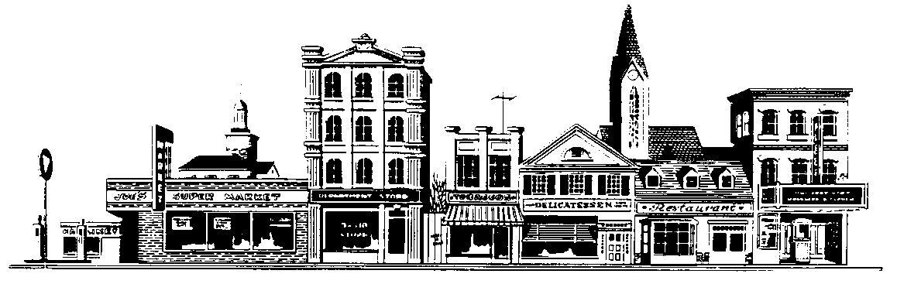
INDIANA REAL ESTATE EXCHANGORS, INC.
P.O. Box 2385 Indianapolis IN 46206

Membership Application
Name: ______________________________________________ Membership Type*: ________________
Firm Name: ____________________________________________ Phone: ______-_______-__________
E-Mail: ___________________________________________________ Fax: ______-_______-__________
Address: ______________________ City: __________________ State: _____ Zip: _________-_______

- I (am) (am not) a licensed real estate person in the state of _____________________.
- I have ______ years of real estate experience of which ______ are in commercial / investment property. My primary area of specialization is _________________________________________.
- I have the following professional designations: ________________________________________.
- I am a member of the following exchange or marketing groups: _________________________.
- I have recently completed the following real estate educational courses:
__________________________________________________ Date _______________________
__________________________________________________ Date _______________________
_________________________________________________ Date _______________________
- I (own) (do not own) commercial / investment real estate.
- I (manage) (do not manage) commercial / investment real estate.
- I (lease) (do not lease) commercial / investment real estate.
- I (broker) (do not broker) commercial / investment real estate.

I am sponsored by: ___________________________________.
signature of sponsor
If accepted for membership, I agree to abide by and support IREX’s By-Laws and Code of Ethics.

Signature ___________________________________________ Date _______________________

*Membership types are: Regular, for licensed Indiana Real Estate professionals ($125); Affiliate, for licensed Real Estate professionals outside Indiana ($25); Associate, for non-licensed real estate related professionals ($125); and Student, for full time college students pursuing a real estate related course of study ($25).

